|  |  |  |
| --- | --- | --- |
| Vocational School of Coding and Innovations | | |
| **Theme:** **Sets** | | |
| **Technical knockout:**  Dimitar Kalchev  Alexander Hristov  Ivan Dimov  Martin Atanasov  Tsvetan Tinev |  | **Mentor**  Petar Georgiev |

Table of content

1. Authors 3

2. Purpose 4

3. Diagram 5

4. Main steps in the implementation of the project 6

5. Problems during development 7

6. Future improvements 8

# Authors

|  |  |  |  |
| --- | --- | --- | --- |
| • | Dimitar Kalchev | <DMKalchev18@codingburgas.bg> | Class XA |
| • | Alexander Hristov | <aihristov18@codingburgas.bg> | Class IXV |
| • | Martin Atanasov | <mvatanasov18@codingburgas.bg> | Class XV |
| • | Tsvetan Tinev | <tatinev18@codingburgas.bg> | Class Xg |
| • | Ivan Dimov | <IIDimov18@codingburgas.bg> | Class XA |

# Purpose

The purpose of the project is to help using the operations which can be done with sets. In the program there are some of the operations. Here is a list of them:

* Union
* Section
* Difference
* Subset
* Symmetric difference

# Diagram

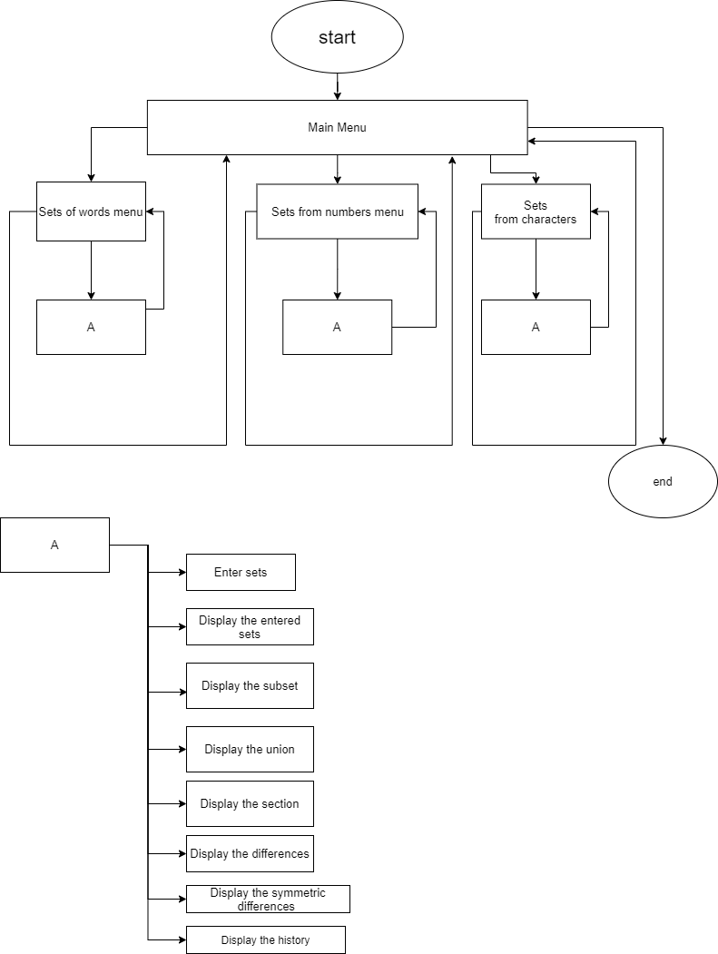

# Main steps in the implementation of the project

* Defining the main idea
* Defining the purpose of the project
* Implementing the project by writing code

The application is written entirely in C++.

# Problems during development

We didn’t have many problems while developing the project, but there are some of them:

* Displaying the sets’ visualization
* Managing the header files
* Formatting the files

# Future improvements

In the future we want to:

* add sets from letters,
* to import the data in excel,
* cloud data base,
* user system.